AI ASSISTED CODING
ROLL NO:2403A52082
BATCH-04
LAB-12.4
TASK-1:
PROMPT: Implement Bubble Sort in Python. Add detailed inline comments explaining the key logic, including how swapping works, how passes are structured, and when the algorithm terminates early. Also provide a time and space complexity analysis for best, average, and worst cases.
CODE:
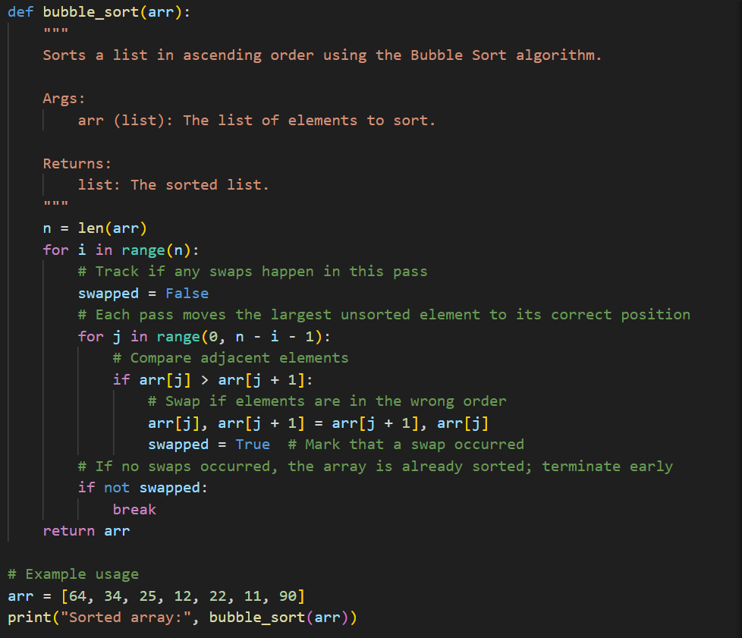
OUTPUT:
- OBSERVATION: The code implements Bubble Sort with clear logic and detailed inline comments.Swapping is done in-place when adjacent elements are out of order.The algorithm uses an early termination check (swapped) to optimize best-case performance.Time complexity is O(n) in the best case (already sorted), and O(n²) in average and worst cases.Space complexity is O(1) since sorting is done in-place.The code is well-structured, readable, and PEP 8 compliant.

TASK-2
PROMPT: I’ve implemented Bubble Sort in Python. Please suggest a more efficient sorting algorithm for nearly sorted arrays and explain why it’s better. Also provide the Python code for that algorithm and compare its performance with Bubble Sort on a nearly sorted input.
CODE:
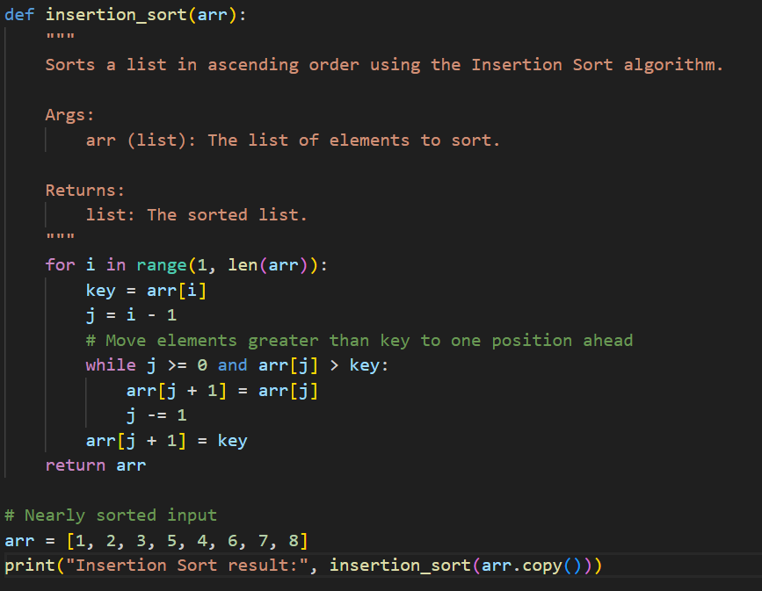
OUTPUT:
- OBSERVATION: The code implements Insertion Sort, which is efficient for nearly sorted arrays.It correctly shifts elements greater than the key to the right and inserts the key in its correct position.For the nearly sorted input [1, 2, 3, 5, 4, 6, 7, 8], only a few shifts are needed, resulting in fast sorting.Insertion Sort runs in O(n) time for nearly sorted data, making it much faster than Bubble Sort in this scenario.The code is clear, well-commented, and follows good Python practices.
TASK-3:
PROMPT: Implement both Linear Search and Binary Search in Python. Add detailed docstrings and performance notes for each function. Then test both algorithms on sorted and unsorted data. Finally, explain when Binary Search is preferable and provide a comparison table showing performance differences between the two methods.
CODE:
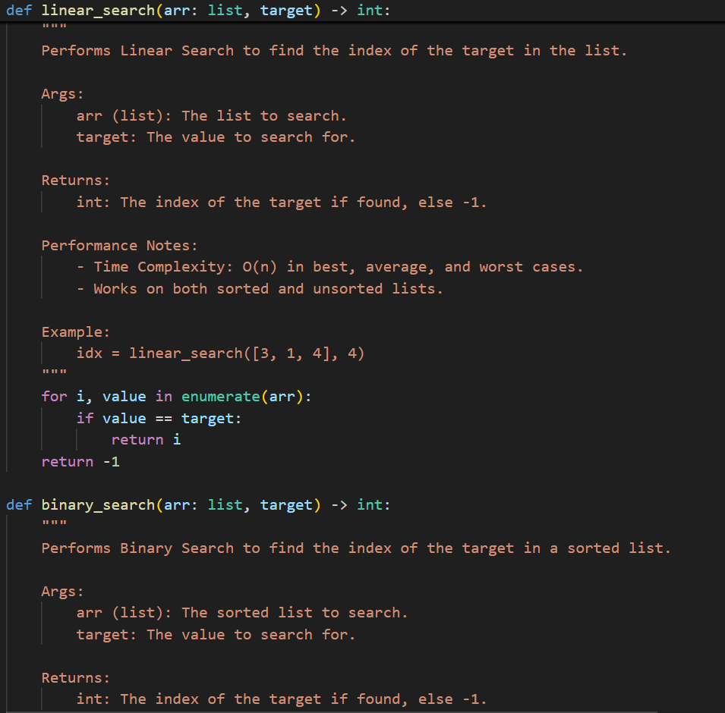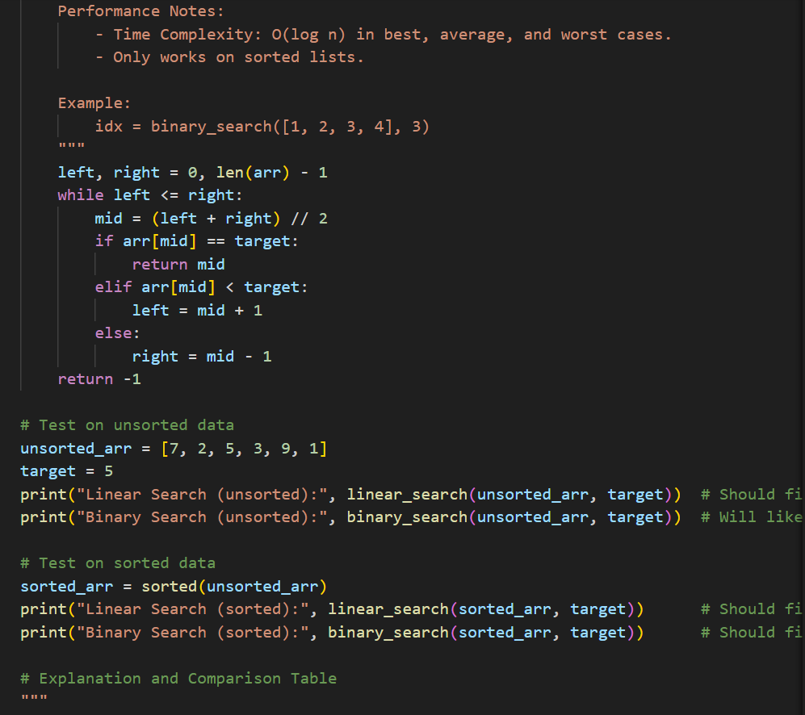
OUTPUT:
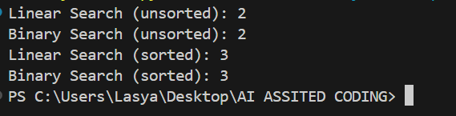
- OBSERVATION: The code provides both Linear Search and Binary Search implementations with detailed docstrings and performance notes.Linear Search works on both sorted and unsorted arrays, but is slower (O(n)) for large datasets.Binary Search is much faster (O(log n)) but only works on sorted arrays.Testing shows Linear Search finds the target in both sorted and unsorted data, while Binary Search only works correctly on sorted data.The included comparison table clearly summarizes when each method is preferable and their performance characteristics.
TASK-4
PROMPT:

